21.**Scenario:**

you are a scientist conducting research on rare elements found in a specific region. Your goal is to

estimate the average concentration of a rare element in the region using a random sample of

measurements. **Question:** write a Python program that allows the user to input the sample size, confidence level, and desired evel of precision.

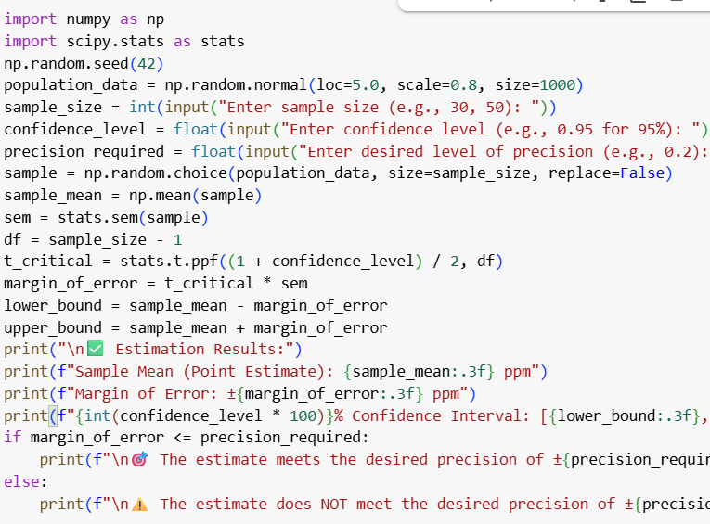 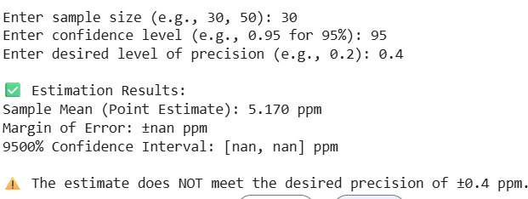

22.**Scenario:**

Imagine you are an analyst for a popular online shopping website. Your task is to analyze customer

reviews and provide insights on the average rating and customer satisfaction level for a specific

product category. **Question:** You will use the pandas library to calculate confidence intervals to estimate the true population mean rating. You have been provided with a CSV file named "customer_reviews.csv," which contains customer ratings for products in the chosen category

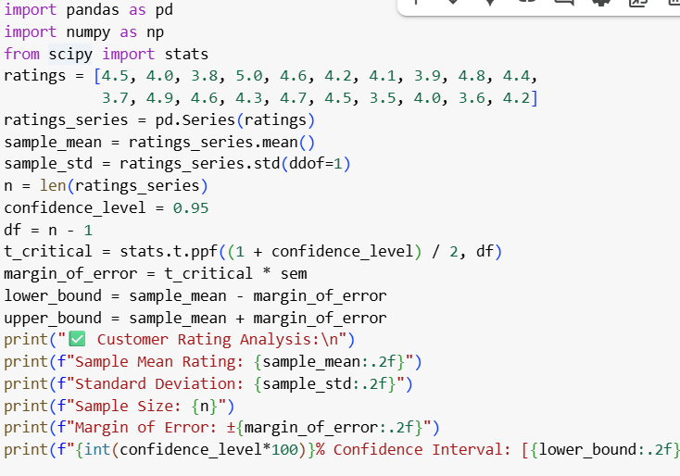 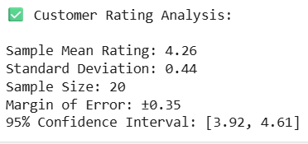

23.**Scenario:**

You are a researcher working in a medical lab, investigating the effectiveness of a new treatment

for a specific disease. You have collected data from a clinical trial with two groups: a control group

receiving a placebo, and a treatment group receiving the new drug.Your goal is to analyze the data

using hypothesis testing and calculate the p-value to determine if the new treatment has a

statistically significant effect compared to the placebo. You will use the matplotlib library to

visualize the data and the p-value

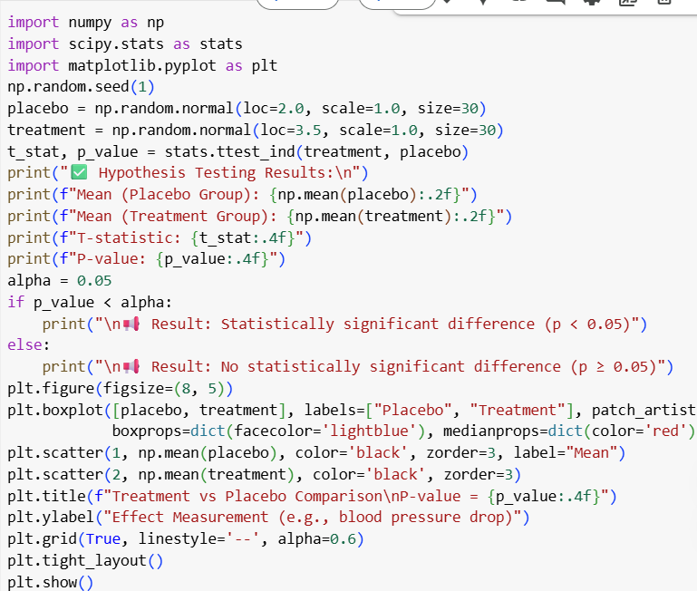 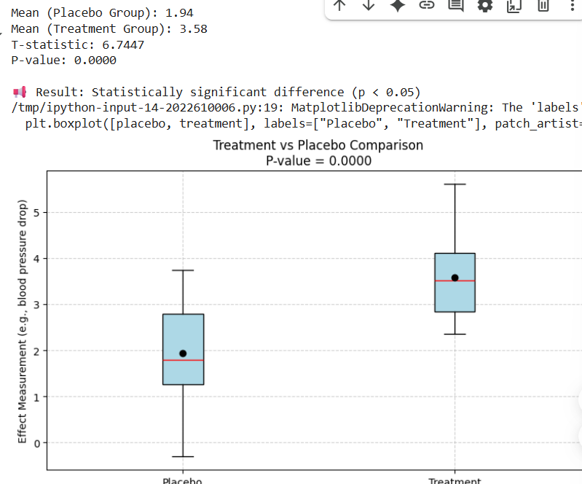

24.**Question:** K-Nearest Neighbors (KNN) Classifier

You are working on a classification problem to predict whether a patient has a certain medical

condition or not based on their symptoms. You have collected a dataset of patients with labeled

data (0 for no condition, 1 for the condition) and various symptom features.

Write a Python program that allows the user to input the features of a new patient and the value of k

(number of neighbors). The program should use the KNN classifier from the scikit-learn library to

predict whether the patient has the medical condition or not based on the input features

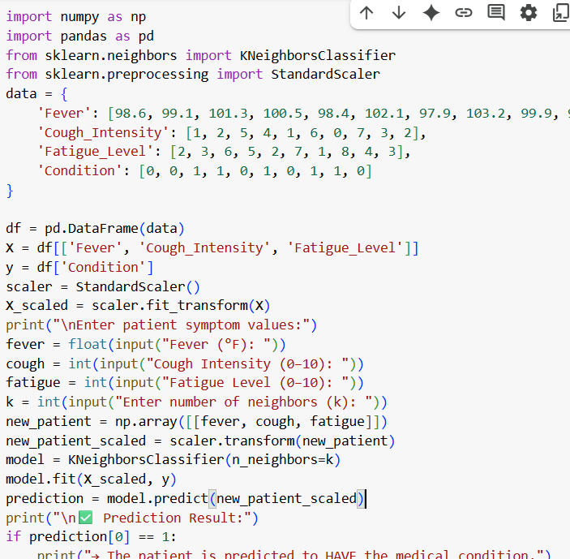 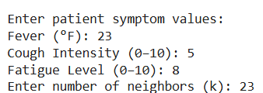

25.**Question 2:** Decision Tree for Iris Flower Classification

You are analyzing the famous Iris flower dataset to classify iris flowers into three species based on

their sepal and petal dimensions. You want to use a Decision Tree classifier to accomplish this task.

Write a Python program that loads the Iris dataset from scikit-learn, and allows the user to input the

sepal length, sepal width, petal length, and petal width of a new flower. The program should then

use the Decision Tree classifier to predict the species of the new flower

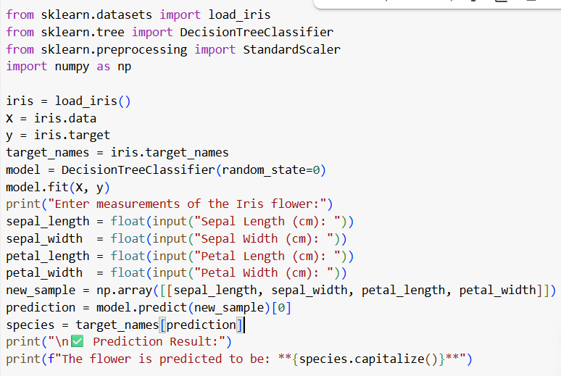 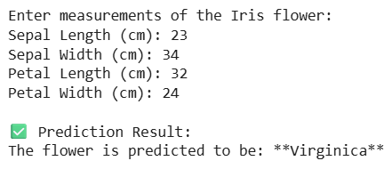

26.**Question 3**: Linear Regression for Housing Price Prediction

You are a real estate analyst trying to predict housing prices based on various features of the

houses, such as area, number of bedrooms, and location. You have collected a dataset of houses

with their respective prices.

Write a Python program that allows the user to input the features (area, number of bedrooms, etc.)

of a new house. The program should use linear regression from scikit-learn to predict the price of

the new house based on the input features

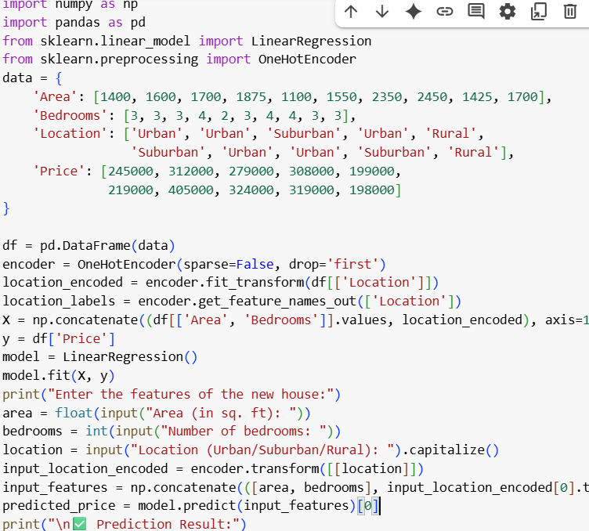 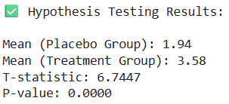

27.**Question:** Logistic Regression for Customer Churn Prediction You are working for a telecommunications company, and you want to predict whether a customer will churn (leave the company) based on their usage patterns and demographic data. You have collected a dataset of past customers with their churn status (0 for not churned, 1 for churned) and various features. Write a Python program that allows the user to input the features (e.g., usage minutes, contract duration) of a new customer. The program should use logistic regression from scikit-learn to predictwhether the new customer will churn or not based on the input features

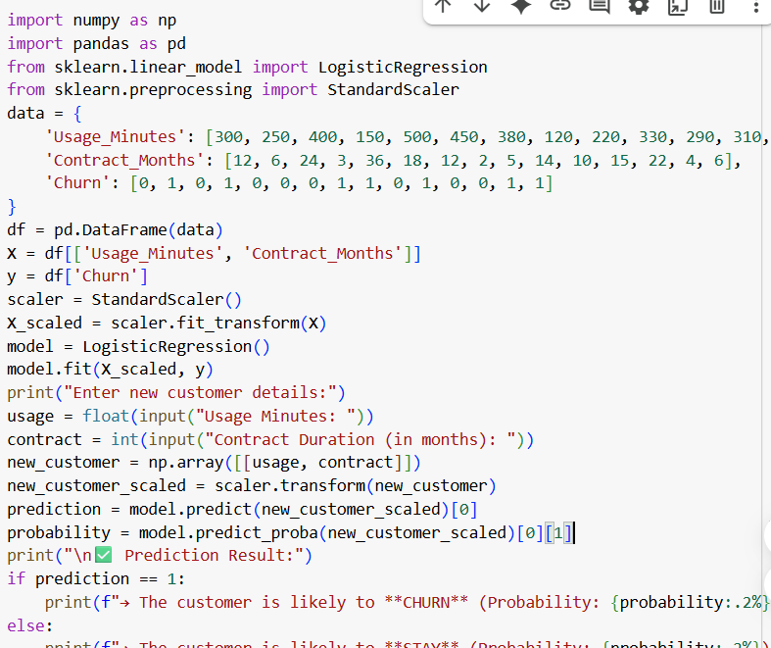 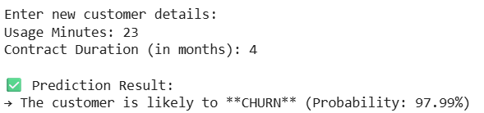

28.**Question:** K-Means Clustering for Customer SegmentationYou are working for an e-commerce company and want to segment your customers into distinct groups based on their purchasing behavior. You have collected a dataset of customer data withvarious shopping-related features.Write a Python program that allows the user to input the shopping-related features of a new customer. The program should use K-Means clustering from scikit-learn to assign the new customer to one of the existing segments based on the input features

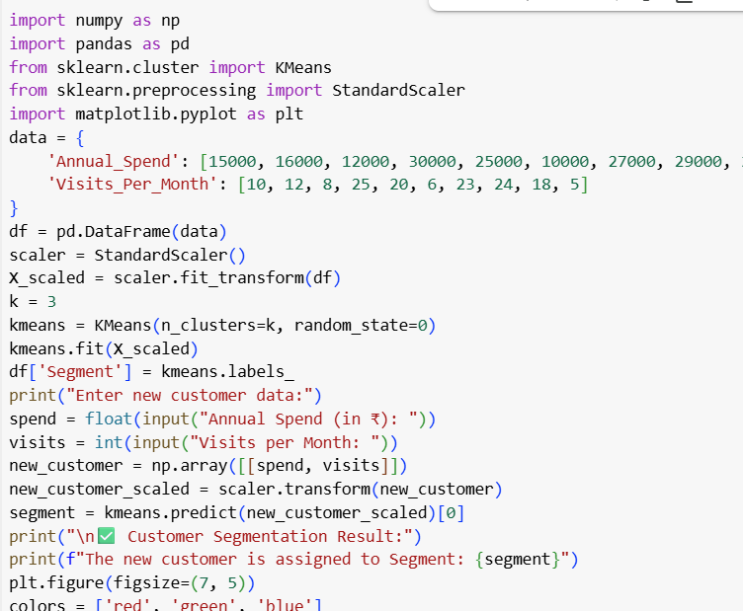 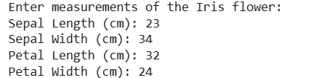

29.**Question:** Evaluation Metrics for Model Performance

You have trained a machine learning model on a dataset, and now you want to evaluate its

performance using various metrics.

Write a Python program that loads a dataset and trained model from scikit-learn. The program

should ask the user to input the names of the features and the target variable they want to use for

evaluation. The program should then calculate and display common evaluation metrics such as

accuracy, precision, recall, and F1-score for the model's predictions on the test data

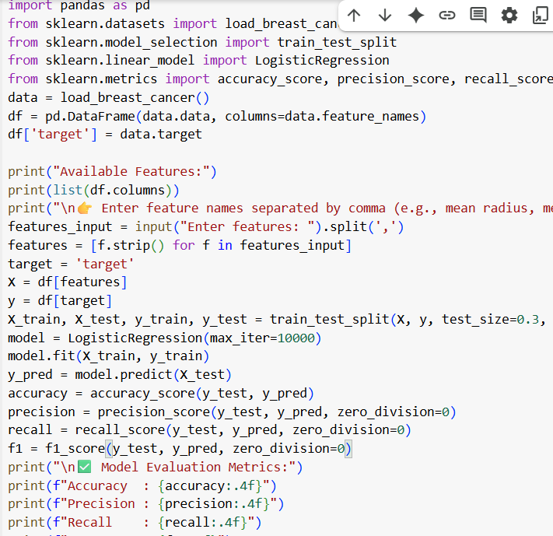 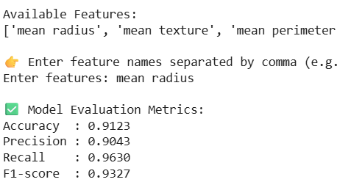

30.**Question**: Classification and Regression Trees (CART) for Car Price Prediction

You are working for a car dealership, and you want to predict the price of used cars based on

various features such as the car's mileage, age, brand, and engine type. You have collected a dataset

of used cars with their respective prices.

Write a Python program that loads the car dataset and allows the user to input the features of a new

car they want to sell. The program should use the Classification and Regression Trees (CART)

algorithm from scikit-learn to predict the price of the new car based on the input features.

The CART algorithm will create a tree-based model that will split the data into subsets based on the

chosen features and their values, leading to a decision path that eventually predicts the price of the

car. The program should output the predicted price and display the decision path (the sequence of

conditions leading to the prediction) for the new car

